New measures phenology

In plants when phen t1 = phen t2 (n = 23 plants) 🡪 phen t2 was corrected according to

phen t2 = phen t2 * n_fl (fitted to the rest of the plants)

The corrected phen t2 was then used to calculate the new phenology measures

1. Average 2 dates





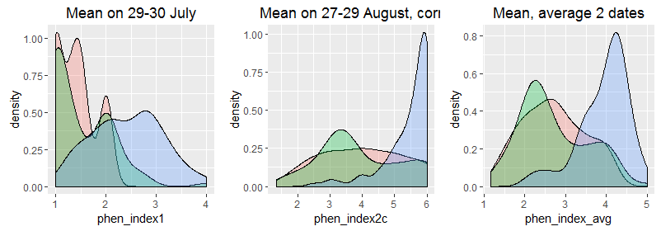

2. Extrapolating from linear model for each plant: Julian day when phen_index=3 (higher limit set to Sept 15, corrected for 20 plants)

3. Extrapolation from linear model for each plant: Julian day when phen_index=2 (higher limit set to Sept 7, corrected for 5 plants)

Comparison distribution 3 measures:

